

MARITIME MUSEUM OF TASMANIA INC.

Notice is hereby given to members that the ANNUAL GENERAL MEETING of the above will be held at the Royal Yacht Club of Tasmania, 15 Marieville Esplanade, Sandy Bay at 11.30 am, Tuesday 18 November 2025. Only financial members may attend the meeting.

Per Rule 19 of the Constitution, Motions of Notice need to be lodged with the Public Officer fourteen (14) days prior to the meeting, that is no later than 5.00 p.m. Monday, 3 November 2025. No Motions will be accepted from the floor.

AGENDA

- Welcome by President
- Apologies
- Confirmation of minutes of Previous AGM
- President’s Annual Report
- Treasurer’s & Financial Annual Reports
- Election results for committee members
- Appointment of Auditor
- Appointment of Patron
- Motions of Notice (if any)
- General Business

MARITIME MUSEUM OF TASMANIA INC. - Nomination Form 2025

Nominations for the Office of Vice-President, Secretary and four Ordinary Committee Members of the Association, each for a term of two years, should be made on the form below and must be received by the Public Officer at the Maritime Museum by no later than 5.00 p.m. on Friday 7 November 2025.

Nominees for Committee are accepted in accordance with Rule 25 of the Constitution.
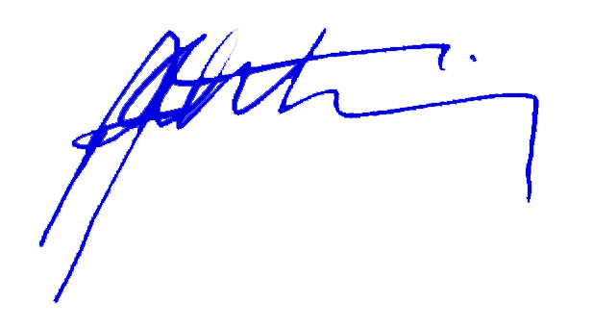

Paul Armstrong,
Acting Secretary, Maritime Museum of Tasmania Inc.

We the Undersigned, hereby nominate …………………………………………………….

For the position of ……………………………………………………

Proposer: …………………………………………………………………………….………
(Print name and signature)

Seconder: ……………………………………………………………………….….…………
(Print name and signature)

I agree to accept the nomination: …………………………………………….….
(Signature)
Date: ………………………………………

